**Name – Milan Sharma Section – 23MAI-1**

**UID – 23MAI10003**

**Computer Vision Assignment**

1. **Compare and contrast the working of spatial and frequency domain image processing methods give example of application where each methods is more suitable. Explain how linear filter, image derivatives, and edge detection techniques can be implemented in both domains. Support your answer with diagram and mathematics formula.**

**Sol.-**

Spatial Domain Image Processing:

Working: Spatial domain processing involves direct manipulation of pixel values in an image. The operations are performed on the image in its original spatial coordinates.

Example Application: Common applications include image smoothing, sharpening, and contrast adjustments. For instance, a Gaussian filter can be applied to blur or smooth an image.

Implementation: One of the fundamental operations in spatial domain processing is the convolution operation. Given an input image (f(x, y)) and a filter kernel ℎ (h(i, j)), the output image (g(x, y)) is obtained by convolving the two:

g(x, y) = sum_{i=-a}^{a} sum_{j=-b}^{b} f(x+i, y+j) h(i, j)

Here, a and b define the size of the filter kernel.

Frequency Domain Image Processing:

Working: In frequency domain processing, images are transformed into their frequency representations using techniques like the Fourier Transform. Image processing operations are then performed in the frequency domain.

Example Application: Frequency domain processing is often used for tasks like image compression and denoising. The Fourier Transform can be applied to remove high-frequency noise.

Implementation: Linear filtering in the frequency domain involves transforming both the image and the filter into the frequency domain using the Fourier Transform, multiplying them pointwise, and then inverse transforming the result back to the spatial domain:

G(u, v) = F(u, v) cdot H(u, v)

Where G(u, v) is the Fourier Transform of the output image, F(u, v) is the Fourier Transform of the input image, and H(u, v) is the Fourier Transform of the filter.

Image Derivatives and Edge Detection:

Spatial Domain: In the spatial domain, image derivatives can be calculated using convolution with derivative masks like Sobel or Prewitt. Edge detection is often performed by thresholding the magnitude of the gradient.

Frequency Domain: In the frequency domain, the gradient in the spatial domain corresponds to multiplying the Fourier Transform by the complex frequency response of the derivative filter:

G(u, v) = F(u, v) cdot H(u, v)

Here, G(u, v) is the Fourier Transform of the gradient, F(u, v) is the Fourier Transform of the input image, and H(u, v) is the Fourier Transform of the derivative filter.

1. Spatial Filtering technique is used directly on pixels of an image. Mask is usually considered to be added in size so that it has specific center pixel. This mask is moved on the image such that the center of the mask traverses all image pixels.

There are two types:

1. Mean Filter:  
   Linear spatial filter is simply the average of the pixels contained in the neighborhood of the filter mask. The idea is replacing the value of every pixel in an image by the average of the grey levels in the neighborhood define by the filter mask.
2. Order Statistics Filter:  
   It is based on the ordering the pixels contained in the image area encompassed by the filter. It replaces the value of the center pixel with the value determined by the ranking result. Edges are better preserved in this filtering.

Sharpening Spatial Filter: It is also known as derivative filter. The purpose of the sharpening spatial filter is just the opposite of the smoothing spatial filter. Its main focus in on the removal of blurring and highlight the edges. It is based on the first and second order derivative.

Laplacian Filter: Enhances edges by emphasizing regions of rapid intensity change. It is often combined with the original image to enhance details.

Sobel and Prewitt Filters: These filters emphasize vertical and horizontal edges, respectively.

Both Laplacian and Sobel Filters comes under Edge Enhancement Filters

Histogram Equalization: Adjusts the intensity values of an image to enhance the overall contrast. It redistributes the pixel values to cover the entire intensity range.

Example to show Sobel and Laplace filters along with various enhancements -

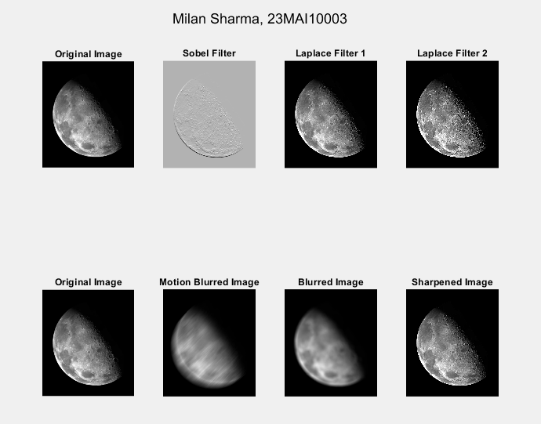

2. Frequency Domain Filters are used for smoothing and sharpening of image by removal of high or low frequency components. Sometimes it is possible of removal of very high and very low frequency. Frequency domain filters are different from spatial domain filters as it basically focuses on the frequency of the images. It is basically done for two basic operation i.e., Smoothing and Sharpening.

1. Low pass filter :  
   Low pass filter removes the high frequency components that means it keeps low frequency components. It is used for smoothing the image. It is used to smoothen the image by attenuating high frequency components and preserving low frequency components.

Mechanism of low pass filtering in frequency domain is given by:

G(u, v) = H(u, v) . F(u, v)

where F(u, v) is the Fourier Transform of original image

and H(u, v) is the Fourier Transform of filtering mask

1. High pass filter :  
   High pass filter removes the low frequency components that means it keeps high frequency components. It is used for sharpening the image. It is used to sharpen the image by attenuating low frequency components and preserving high frequency components.

Mechanism of high pass filtering in frequency domain is given by:

G(u, v) = H(u, v) . F(u, v)

H(u, v) = 1 - H'(u, v)

where H(u, v) is the Fourier Transform of high pass filtering

and H'(u, v) is the Fourier Transform of low pass filtering

1. Band pass filter :  
   Band pass filter removes the very low frequency and very high frequency components that means it keeps the moderate range band of frequencies. Band pass filtering is used to enhance edges while reducing the noise at the same time.

Example to show High Pass ad Low Pass along with Fourier Spectra -

